Urban Air Quality Prediction Using Machine Learning
Ahmed Deraz (24046227) and John Davies (24024782)
Ahmed2.Deraz@live.uwe.ac.uk
Abstract
This study applies supervised machine learning to predict the Health Risk Score from urban air quality and weather data. Using the UrbanAirNet dataset — 1,000 daily records across 10 US cities — we evaluate three regression models: Linear Regression as a baseline, Random Forest, and Gradient Boosting. After a chronological 80/20 train-test split and preprocessing of 33 engineered features, Linear Regression achieved the best performance (MAE = 0.1079, RMSE = 0.1326), outperforming both ensemble methods (Random Forest: MAE = 0.1583; Gradient Boosting: MAE = 0.1458). Results indicate the target variable has predominantly linear relationships with the input features, and that model complexity does not guarantee improved accuracy on small, well-structured tabular datasets.
1 Introduction
Urban air quality is a major public health concern. Prolonged exposure to air pollutants such as particulate matter, nitrogen dioxide, and ozone is strongly linked to respiratory and cardiovascular disease. Accurately predicting a composite Health Risk Score — which integrates multiple pollutant and weather signals — enables authorities to issue timely warnings and proactively allocate health resources, making it a valuable goal for both public health and machine learning research.
This project compares three regression approaches: Linear Regression as an interpretable baseline, Random Forest (bagging ensemble), and Gradient Boosting (sequential boosting ensemble). All models are evaluated on an identical chronological train-test split to ensure fair, leakage-free comparison. Our aims are to: (1) build a reproducible preprocessing pipeline for tabular environmental data; (2) evaluate whether ensemble methods offer meaningful gains over a linear baseline on this dataset; and (3) identify the environmental features most predictive of health risk.
Our key finding is that Linear Regression (MAE = 0.1079) outperforms both ensemble methods, suggesting that the Health Risk Score has a predominantly linear structure. This highlights the importance of baseline establishment and motivates our discussion of why complexity did not help.
2 Related Work
The prediction of urban air quality and health risk using machine learning has attracted significant research attention. This section critically appraises three closely related published works.
Madan et al. (2020) conducted a broad review of ML approaches for air quality prediction, covering Random Forest, SVM, and ANN. Their review identifies Random Forest as a strong performer on classification tasks, which informed our choice to include it. However, their focus on binary classification (hazardous vs. safe) differs from our continuous regression task, and none of the reviewed studies predict a composite health risk score. Our work extends beyond their scope by including Gradient Boosting and framing the problem as regression.
Martinez et al. (2018) forecast PM2.5 concentration in Bogotá using ML techniques, achieving strong results with tree-based methods. Like our study, they use weather features and real-world urban data for a health-relevant prediction task. However, their dataset is single-city and their approach is primarily statistical. Our multi-city dataset and fully automated sklearn pipeline offers broader geographic scope and reproducibility.
Ruby et al. (2024) combine Gradient Boosted Regression Trees (GBRT) with CNN and LSTM in a hybrid architecture for PM2.5 forecasting. While they achieve high accuracy, their model is computationally intensive and difficult to interpret. Our work deliberately prioritises interpretability alongside accuracy — critical for public health applications where stakeholders must understand and trust model outputs. This positions our study as complementary to deep learning approaches.
3 Data
3.1 Dataset Selection and Justification
We selected the UrbanAirNet: Urban Air Quality and Weather Dataset (Kaggle, 2024) for three reasons: (1) it combines both air quality and meteorological variables in a single structured dataset, avoiding the need to join multiple sources; (2) it covers 10 geographically diverse US cities across a full year, providing seasonal and regional variation; and (3) it includes a pre-computed Health Risk Score target variable suited to supervised regression. Alternative datasets such as the UCI Air Quality dataset (De Vito et al., 2008) were considered but rejected due to single-city scope and extensive missing values. The dataset contains 1,000 daily records from September 2024 to September 2025.
3.2 Preprocessing
The raw dataset contains 46 columns. Two columns were removed due to high missingness: preciptype (62% missing) and Condition_Code (43% missing). Six categorical columns (City, Season, Day_of_Week, conditions, icon, preciptype) were ordinally encoded and Is_Weekend mapped to 0/1, yielding 33 features. All numeric features were standardised using StandardScaler to zero mean and unit variance, ensuring Linear Regression coefficients are comparable.
A chronological 80/20 split (800 train / 200 test) was applied rather than random shuffling, to prevent data leakage from future time periods into the training set — a critical consideration for time-structured data. The target Health_Risk_Score is continuous (range 8.49–11.49, mean 9.73, std 0.38).
4 Methods
4.1 Alternative Methods Considered
Several alternative algorithms were evaluated before selecting the final three. Support Vector Regression (SVR) was considered but excluded due to its poor scalability on datasets with many features and its sensitivity to kernel and regularisation hyperparameters, which would have significantly increased tuning complexity. K-Nearest Neighbours Regression (KNN) was considered but rejected as it performs poorly on high-dimensional data and lacks feature importance outputs, which are central to our analysis. Multi-layer Perceptron (MLP/Neural Network) regression was considered but excluded due to the small dataset size (1,000 records), which is insufficient to train deep networks without overfitting, and the loss of interpretability. Linear Regression, Random Forest, and Gradient Boosting were selected as they offer a clear progression from simple to complex, are well-suited to tabular regression, and all provide feature importance rankings.
4.2 Linear Regression
Linear Regression estimates a weighted linear combination of all 33 input features. With no hyperparameters, it was trained via sklearn's LinearRegressor. It serves as the performance baseline and offers full interpretability through its learned coefficients — important in health-critical applications. Results: MAE = 0.1079, RMSE = 0.1326.
4.3 Random Forest
Random Forest uses bootstrap aggregation (bagging) to train multiple decision trees on random data subsamples, averaging predictions to reduce variance and prevent overfitting. Hyperparameter tuning via 5-fold CV on the training set: estimators [50,100,200,300,500] — best: 100; max depth [None,5,10,15,20] — best: 15. Feature importance calculated via mean impurity decrease. Results: MAE = 0.1583, RMSE = 0.2157.
4.4 Gradient Boosting
Gradient Boosting builds trees sequentially, each correcting residual errors of the previous, achieving lower bias than Random Forest at the cost of higher overfitting risk. Hyperparameter tuning via 5-fold CV: estimators [50,100,200,300,500] — best: 500; learning rate [0.01,0.05,0.1,0.2] — best: 0.1. Results: MAE = 0.1458, RMSE = 0.1871.
4.5 Evaluation Protocol
MAE was chosen as the primary metric because it gives a directly interpretable average error in the same units as the target variable, without over-penalising outliers. RMSE was used as a secondary metric as it penalises larger errors more heavily, revealing whether errors are concentrated or spread. The chronological 80/20 split (800 train / 200 test) mimics real-world forecasting and prevents temporal data leakage. 5-fold CV was applied exclusively to the training set to select hyperparameters; the test set was held out and used once only.
4.6 Ethical Considerations
Miscalibrated health risk predictions could misdirect public health resources or cause unnecessary public alarm, disproportionately affecting communities already facing environmental inequality. Linear Regression offers full interpretability through its coefficients, while ensemble methods act as black boxes — a concern in health-critical applications where stakeholder trust is essential. The dataset covers only 10 US cities, limiting geographic generalisation, and the composite target variable may not directly reflect clinical health outcomes.
5 Experiments
Table 1 presents the performance of all three models on the held-out 200-record test set. Table 2 shows the 5-fold CV tuning results that determined the final hyperparameters.
Model | MAE | RMSE | vs Baseline
Linear Regression | 0.1079 | 0.1326 | Baseline
Random Forest | 0.1583 | 0.2157 | ▲ 46.7% Worse
Gradient Boosting | 0.1458 | 0.1871 | ▲ 35.1% Worse
Table 1: Model performance on the 200-record held-out test set.

Model | Parameter | Values Tested | Best
Random Forest | n_estimators | [50,100,200,300,500] | 100
Random Forest | max_depth | [None,5,10,15,20] | 15
Gradient Boosting | n_estimators | [50,100,200,300,500] | 500
Gradient Boosting | learning_rate | [0.01,0.05,0.1,0.2] | 0.1
Table 2: 5-fold CV hyperparameter tuning results for RF and GB.

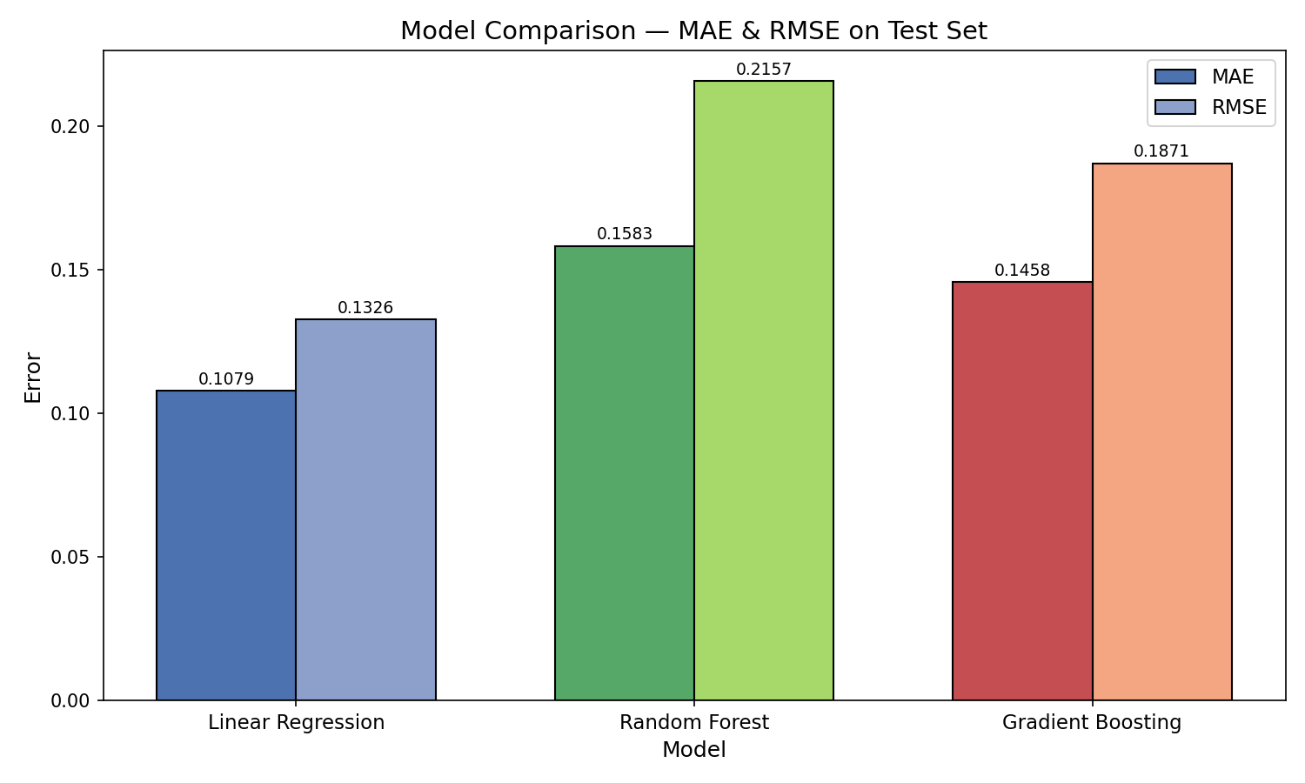
Figure 1: MAE and RMSE comparison across all three models.

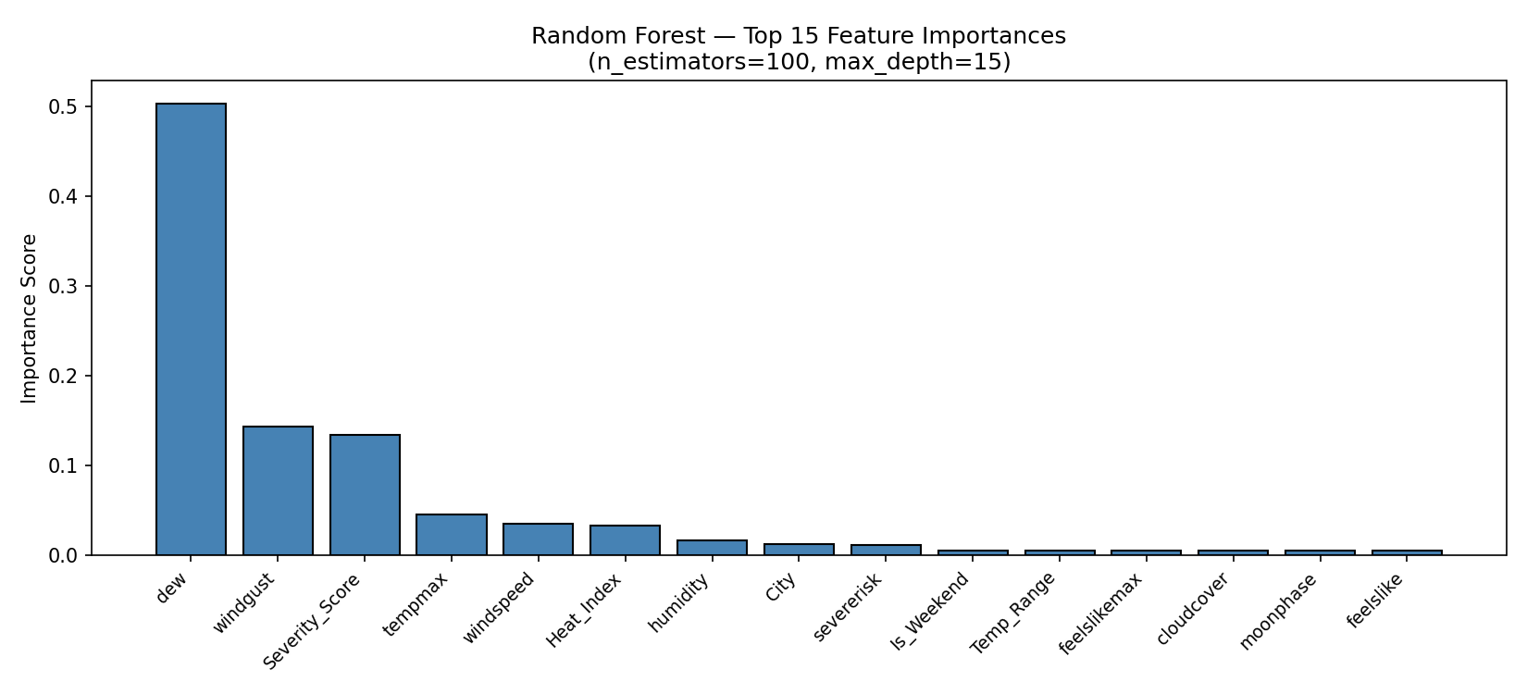
Figure 2: Random Forest — Top 15 feature importances.

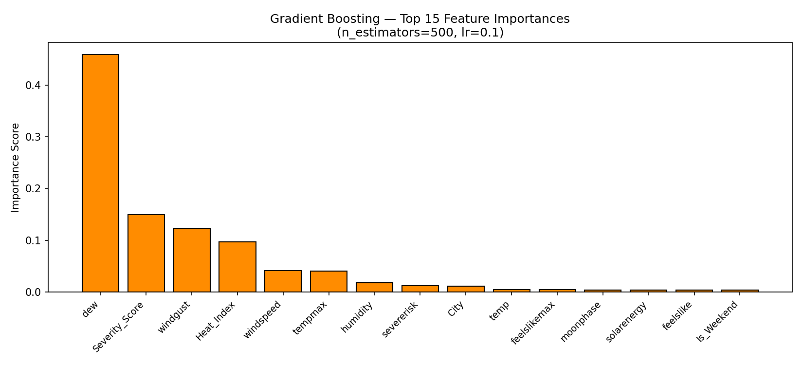
Figure 3: Gradient Boosting — Top 15 feature importances.

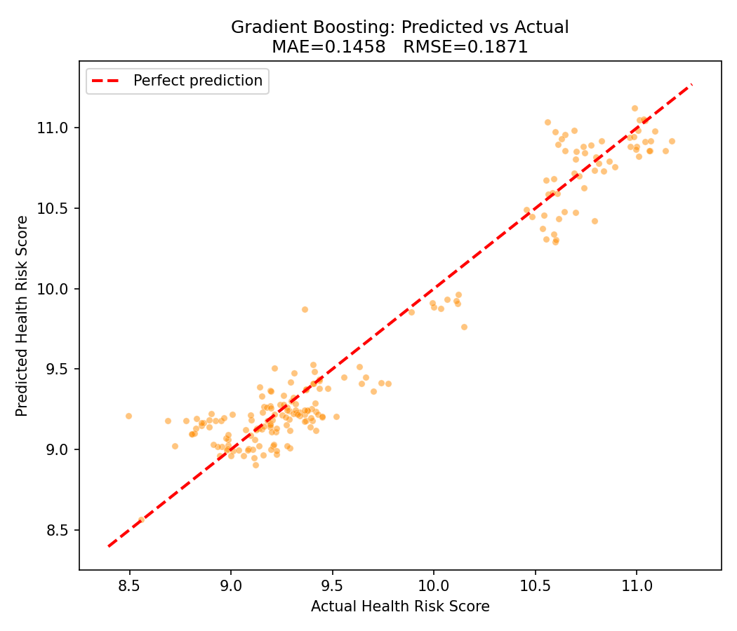
Figure 4: Gradient Boosting — Predicted vs Actual Health Risk Score.

Linear Regression achieved the best MAE, outperforming both ensemble methods (Figure 1). This suggests the Health Risk Score has a predominantly linear relationship with the input features, supported by high correlation between the target and meteorological variables such as dew point and wind gust observed in the EDA. It demonstrates that simpler, interpretable models can be highly effective and confirms the value of establishing a strong baseline before applying more complex methods.
Both Random Forest and Gradient Boosting ranked dew, wind gust, and Severity Score as the top predictors (Figures 2 and 3), consistent with domain knowledge that humidity and wind conditions strongly influence pollutant dispersion. Agreement between both models' feature rankings increases confidence in result interpretability.
The Gradient Boosting scatter plot (Figure 4) shows strong alignment with the ideal prediction line in mid-range values (9.0–9.5), with slight underprediction at higher values (>10.5). Ensemble methods likely underperformed due to the small 1,000-record dataset, which is insufficient to realise their capacity advantage, and to distributional shift in the chronological split causing both RF and GB to struggle with later time-period patterns.
6 Conclusion
This study compared Linear Regression, Random Forest, and Gradient Boosting for predicting Health Risk Score from urban air quality and weather data. Linear Regression achieved the best performance (MAE = 0.1079), demonstrating that ensemble complexity does not guarantee improvement on small, linearly-structured datasets. The result has clear implications: practitioners should always establish an interpretable baseline before deploying complex models, as complexity incurs computational and transparency costs without guaranteed accuracy gains.
Limitations include the small dataset size (1,000 daily records, 10 US cities), which limits generalisation to other regions and climates. Daily granularity prevents intra-day analysis of pollution spikes, and the composite target may not reflect clinical health outcomes directly.
Future work should explore larger multi-city datasets, LSTM networks for temporal modelling, and real-time streaming pipelines. Incorporating socioeconomic variables such as traffic density and industrial proximity may also improve performance. Regional studies with controlled environmental profiles could reduce confounding variability.
References
Madan, T., Sagar, S. and Virmani, D. (2020) Air Quality Prediction using Machine Learning Algorithms – A Review. 2020 2nd International Conference on Advances in Computing, Communication Control and Networking (ICACCCN) [online]. Available from: https://ieeexplore.ieee.org/document/9362916 [Accessed 23 April 2026].
Martinez, N.M., Montes, L.M., Mura, I. and Franco, J.F. (2018) Machine Learning Techniques for PM10 Levels Forecast in Bogotá. 2018 ICAI Workshops (ICAIW) [online]. pp. 1–7. Available from: https://ieeexplore.ieee.org/abstract/document/8554995 [Accessed 23 April 2026].
Ruby, A.U., Chellin, G., Prasannavenkatesan Theerthagiri, Patil, R., Chaithanya, B.N. and Jain, S. (2024) Forecasting PM2.5 Concentration Using Gradient-Boosted Regression Tree with CNN Learning Model. Optical Memory and Neural Networks [online]. 33(1), pp. 86–96. Available from: https://doi.org/10.3103/S1060992X24010077 [Accessed 29 April 2026].

https://proceedings.ijcai.org/info
You may want also to use the package latexsym, which defines all symbols known from the old LAT_{E}X version.
This is how your footnotes should appear.
Note the line separating these footnotes from the text.

